**Assignment - 1**

Write SQL queries for the following:

1. List all the available databases.

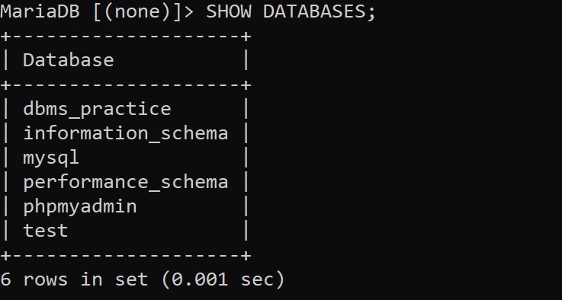

1. Create a database of your name.

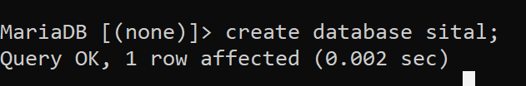

1. Drop the created database and create another database as dbms_practice.



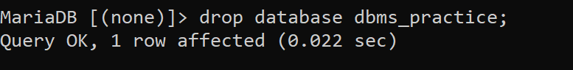

1. Select the dbms_practice database.



1. List all available tables.

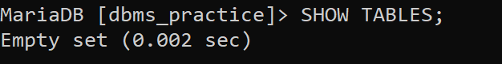

1. Create a table student with id, name, address as the columns.

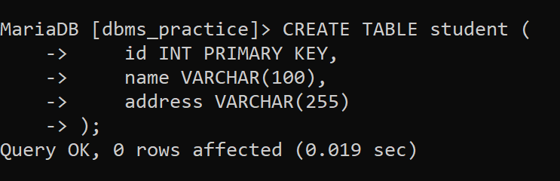

1. See the structure of the table.

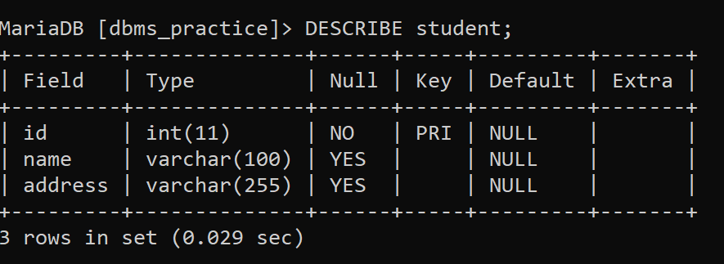

1. Populate the student table with ten tuples.

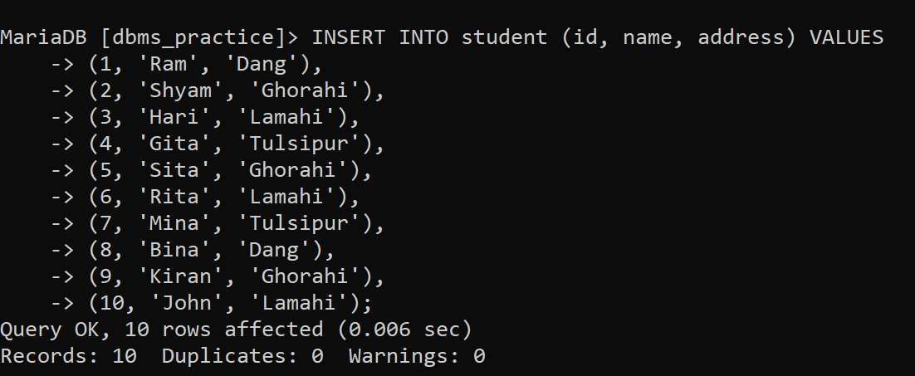

1. Display all the entered data of the table.

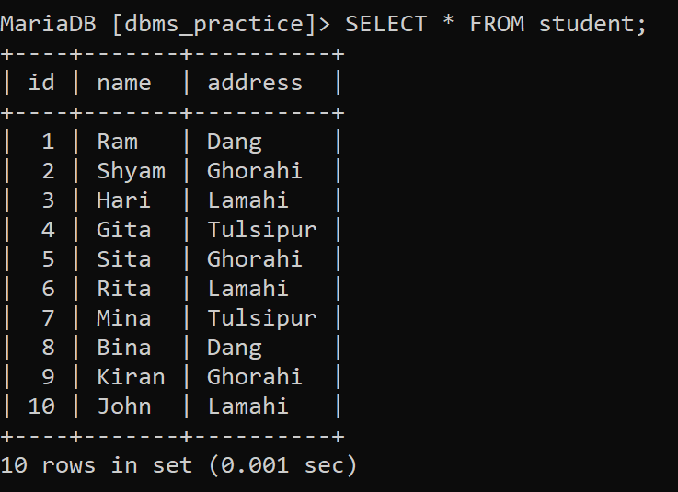

1. Select the students who live in Ghorahi.

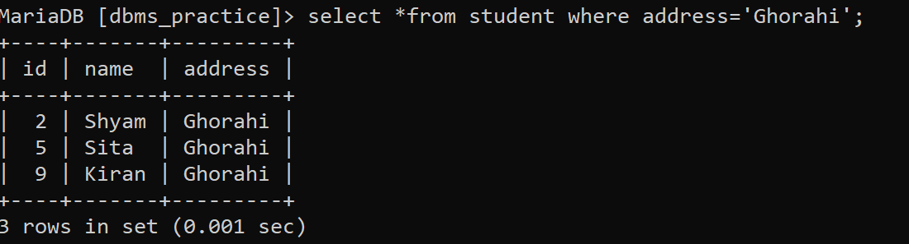

1. Select all the people who name is Ram and lives in Dang.

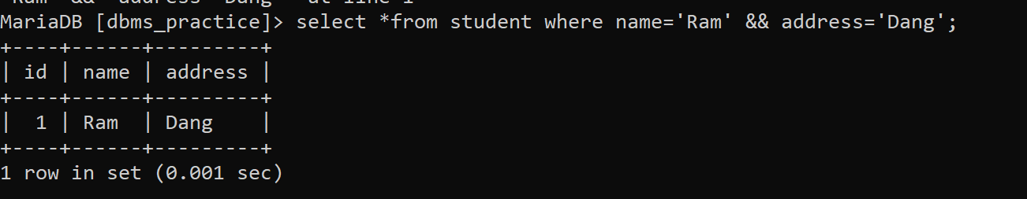

1. Select name and address of the students who lives either in Lamahi or Tulsipur.

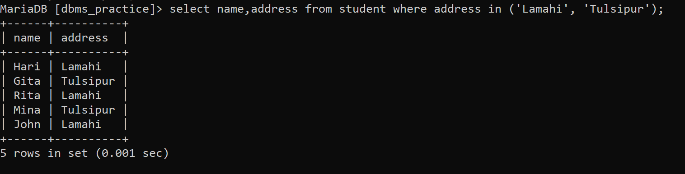

1. Select id and name of all the students.

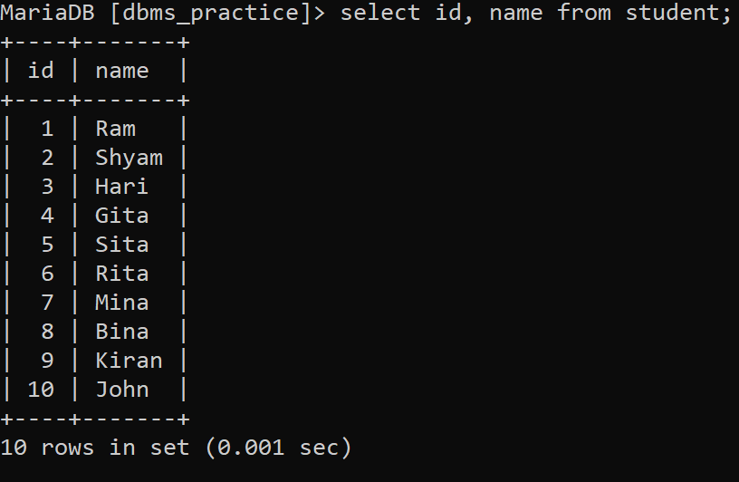

1. 14. Clear all the data of the table at once.



1. 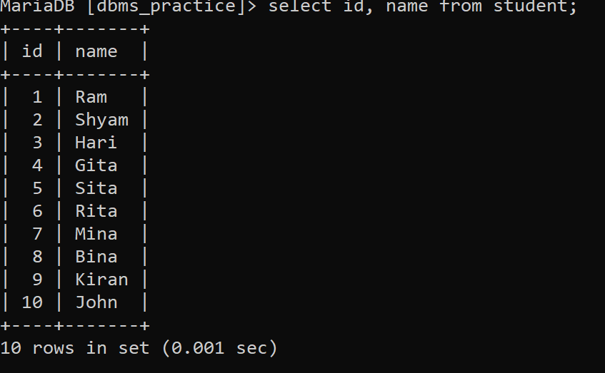
2. Clear all the data of the table at once.

